

**BOSTON | SEATTLE**

**187 Ballardvale St. Suite A195 ●Wilmington, MA 01887● Ph: +1.978.694.1008**

[**getsecure@securityinnovation.com**](mailto:getsecure@securityinnovation.com)**●** [**www.securityinnovation.com**](http://www.securityinnovation.com)

|  |  |
| --- | --- |
| **Document name:** | Insecure Logging |
| **Author(s):** | Dinesh Shetty |



Insecure Logging

# Contact Information

### Technical Contact

Dinesh Shetty

Senior Security Engineer

Email: [dinezh.shetty@gmail.com](mailto:dinezh.shetty@gmail.com)

# Test Configuration

The following is required to verify this issue:

* Download the latest version of the Android-InsecureBankv2 apk from <https://github.com/dineshshetty/Android-InsecureBankv2>
* Download Android SDK from <http://developer.android.com/sdk/index.html>

# Test Steps

1. Copy the InsecureBankv2.apk file to the “platform-tools” folder in the Android SDK and then use the below command to push the downloaded Android-InsecureBankv2 application to the emulator.

./adb install InsecureBankv2.apk

1. Now, enter the below command to start viewing logs from the emulator:

./adb logcat

1. 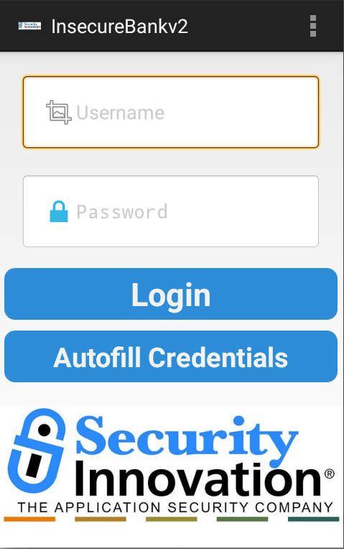Launch the installed InsecureBankv2 application on the Emulator. The following screenshot shows the default screen available to a normal user after login.
2. Enter valid credentials and click on “Login”. The following screenshot shows that the credentials are logged on the console.

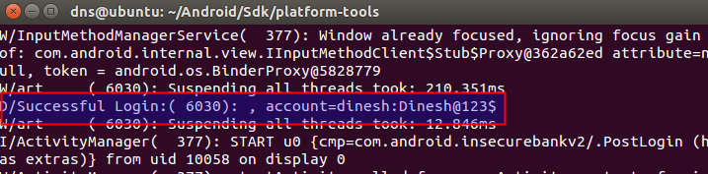

1. Navigate to the “Change Password” page and enter new credentials. The following screenshot shows that the new credentials are logged on the console which is shared between all the applications.

